/*1. Write a program (WAP) to display "Hello World" on console display.
MANTAVYA KUMAR;23-09-2025*/
#include<stdio.h>
int main()
{
printf("Hello World");
return 0;
}

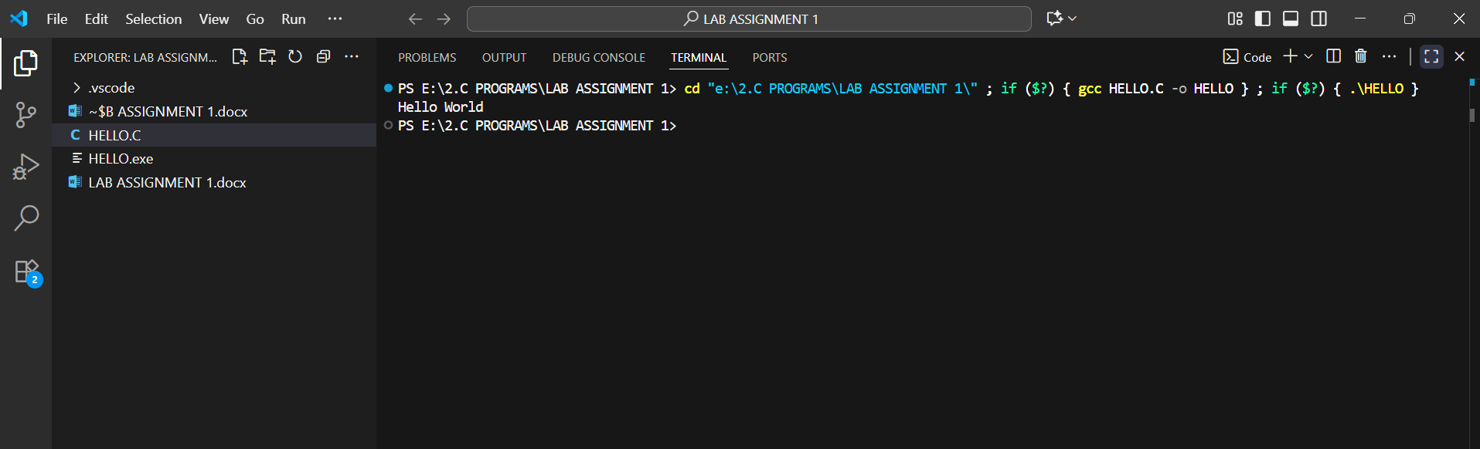

/*2. WAP to input an integer and display it.
MANTAVYA KUMAR;23-09-2025*/
#include<stdio.h>
int main()
{
int A;
printf("PLEASE ENTER AN INTEGER");
scanf("%d",&A);
printf("\nTHE INTEGER ENTERED IS %d",A);
return 0;
}
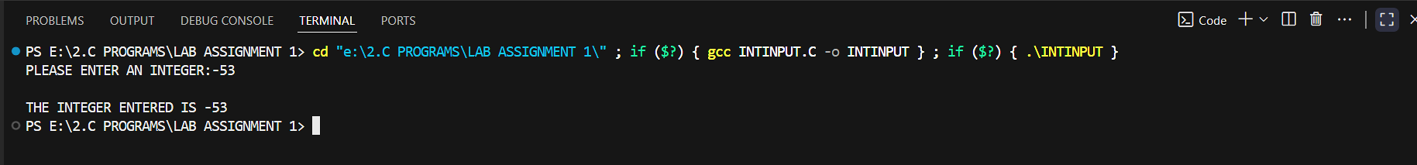
/*3. WAP to input a decimal number and display it.
MANTAVYA KUMAR;23-09-2025*/
#include<stdio.h>
int main(){
float D;
printf("ENTER A DECIMAL NUMBER:");
scanf("%f",&D);
printf("THE ENTERED DECIMAL NUMBER IS %f",D);
return 0;
}
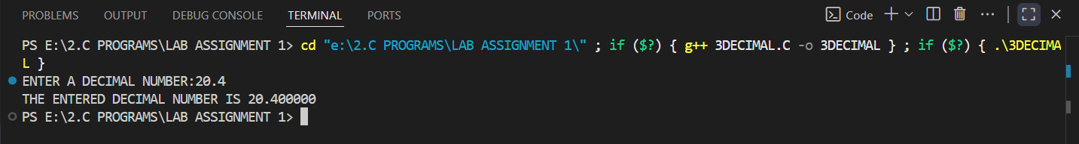

/*4. WAP to input a character and display it.
MANTAVYA KUMAR;23-09-2025*/
#include<stdio.h>
int main(){
char C;
printf("ENTER A CHARACTER:");
scanf("%c",&C);
printf("\n THE CHARACTER ENTERED BY THE USER IS %c",C);
}
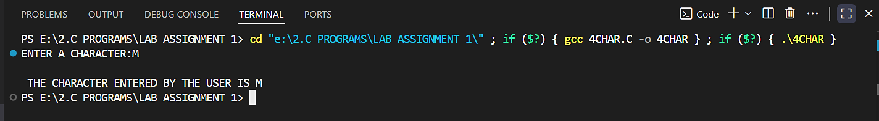
/*5. WAP to add, subtract and multiply numbers. [ Note: Avoid Divide operation, we will do it in next lab after type
casting];MANTAVYA KUMAR;24-09-2025 */
#include<stdio.h>
int main(){
float A,B,SUM,S,M;
printf("ENTER THE FIRST NUMBER");
scanf("%f",&A);
printf("ENTER THE FIRST NUMBER");
scanf("%f",&B);
SUM=A+B;
S=A-B;
M=A*B;
printf("THE SUM OF THE ENTERED NUMBERS IS %f",SUM);
printf("\nTHE DIFFERENCE OF THE ENTERED NUMBERS WHEN SECOND NUMBER IS SUBTRACTED FROM THE FIRST NUMBER %f",S);
printf("\nTHE MULTIPLICATION OF THE ENTERED NUMBERS IS %f",M);
return 0;
}
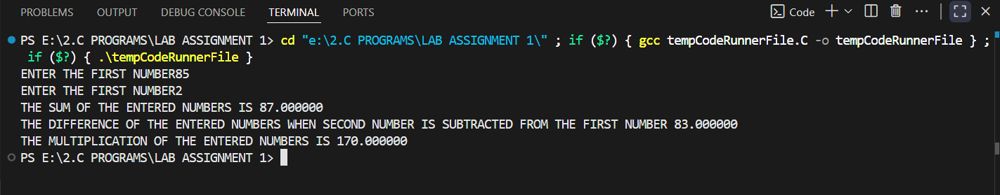

/*6. WAP to calculate gross salary of a person, where gross_salary=basic+da+ta and da is 10% of basic and ta is
12% of basic.;MANTAVYA KUMAR;24-09-2025*/
#include<stdio.h>
int main(){
int BS;
float GS;
printf("PLEASE ENTER THE BASIC SALARY OF THE EMPLOYEE :");
scanf("%d",&BS);
GS=BS+((BS*10)/100)+((BS*12)/100);
printf("THE GROSS SALARY OF THE EMPLOYEE AFTER CONSIDERING TA AND DA IS %f",GS);
return 0;
}
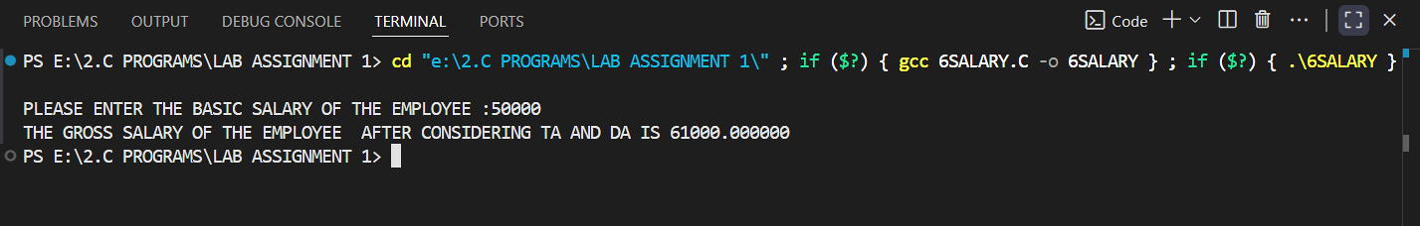

/*7.Two numbers are input through the keyboard into location c and d. WAP to interchange the contents of c and d using third variable.*/
#include<stdio.h>
int main(){
int C,D,E;
printf("ENTER THE NUMBER TO BE STORED IN LOCATION c:");
scanf("%d",&C);
printf("ENTER THE NUMBER TO BE STORED IN LOCATION d:");
scanf("%d",&D);
E=C;
C=D;
D=E;
printf("THE NUMBER AT LOCATION c is %d",C);
printf("\nTHE NUMBER AT LOCATION d is %d",D);
return 0;
}
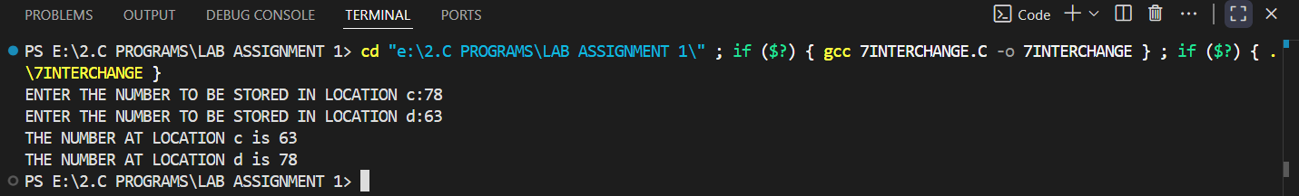
/*8. Two numbers are input through the keyboard into location c and d. WAP to interchange the contents of c and d
without using a third variable
MANTAVYA KUMAR;24-09-2025*/
#include <stdio.h>
int main(){
int C,D;
printf("ENTER THE NUMBER TO BE STORED IN LOCATION c: ");
scanf("%d", &C);
printf("ENTER THE NUMBER TO BE STORED IN LOCATION d: ");
scanf("%d", &D);
C=C+D;
D=C-D;
C=C-D;
printf("NUMBERS AFTER SWAP ARE\n");
printf("%d\n", C);
printf("%d ",D);
return 0;
}
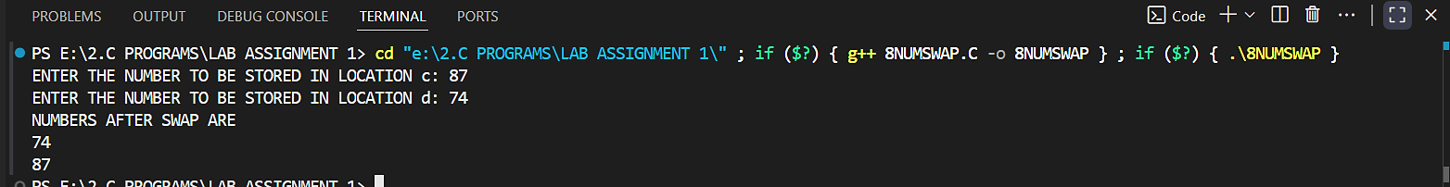

/*9. WAP for area of a circle.
MANTAVYA KUMAR;24-09-2025*/
#include<stdio.h>
#include<math.h>
int main(){
float R,A;
printf("PLEASE ENTER THE RADIUS(IN METRES) OF THE CIRCLE TO FIND ITS AREA : ");
scanf("%f",&R);
A=M_PI*(pow(R,2));
printf("THE AREA(IN SQUARE METRES) OF THE CIRCLE WITH THE ENTERED RADIUS IS: %f",A);
return 0;
}
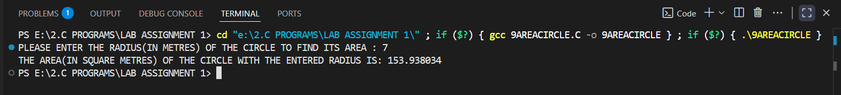
/*10. WAP for simple interest and compound interest. ;MANTAVYA KUMAR;25-09-2025*/
#include<stdio.h>
#include<math.h>
int main(){
float P,R,T,SI,CI;
printf("ENTER THE PRINCIPAL AMOUNT: ");
scanf("%f",&P);
printf("ENTER RATE OF INTEREST PER ANNUM: ");
scanf("%f",&R);
printf("ENTER THE DURATION OF INTEREST IN YEARS: ");
scanf("%f",&T);
SI=((P*R*T)/100);
CI=P*(pow((1+(R/100)),T));
printf("THE SIMPLE INTEREST IS %f",SI);
printf("THE COMPOUND INTEREST IS %f",CI);
return 0;
}
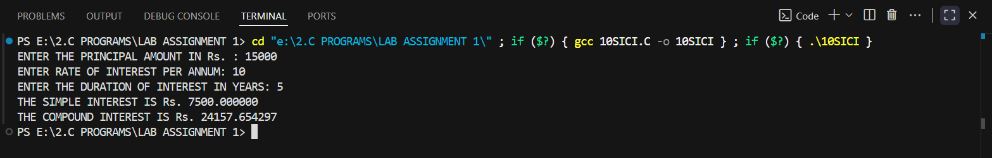

/*11. If a 5-digit number is input through the keyboard, then write a program to reverse the number.
MANTAVYA KUMAR;01-09-2025*/
#include<stdio.h>
int main(){
int A;
printf("ENTER THE FIVE DIGIT NUMBER TO BE REVERSED: ");
scanf("%d",&A);
int REV;
REV=(A%10)*10000+((A%100)-(A%10))*100+((A%1000)-(A%100))*1+((A%10000)-(A%1000))/100+(A/10000);
printf("THE NUMBER AFTER THE REVERSAL IS: %d",REV);
return 0;
}
